8 March 2023

Dear Parents/Carers,

RE: Girls on Fire - Expression of Interest - 15 positions

Willyama High School’s female students have the opportunity to take part in the Girls on Fire Day Camp at the Broken Hill fire station.

Single day camps involve students visiting a designated site to experience frontline emergency service education and training via a mix of presentations from facilitators, individual and class activities, and disaster and emergency simulations.

When : Wednesday 5 April 2023
Where : Broken Hill Fire Station
Cost : Nil

These single day camps involve physical activity, teamwork and a focus on providing a snapshot of the day in the life of emergency services.

Up to 15 positions are available. If interested, please put your name down at the Front Office as soon as possible.

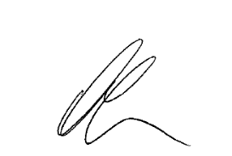
Yours faithfully
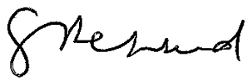

Anthony Tidball Grant Shepherd
Careers Adviser Principal

