Willyama High School

Digital Classrooms Handbook

Table of Contents
1. Student login 2
2. Logging onto the Student Portal & accessing emails 2
3. Accessing Microsoft Office 365 3
3.1 Installing Microsoft Office apps for students. 3
4. Accessing and navigating Microsoft Teams 4
4.1 Accessing Microsoft Teams 4
4.2 Accessing classes within Microsoft Teams 4
4.3 Navigating within a Team 5
4.4 Downloading Microsoft Teams 5
5. Class Notebook 6
5.1 Opening and navigating Class Notebook 6
5.2 Working in Class Notebook 8
5.3 Copying and pasting pages in OneNote 9
5.4 Adding a file in Class Notebook 10
6. Files in Microsoft Teams 11
6.1 Accessing files in Teams 11
6.2 Editing or downloading files from Teams 11
6.3 Adding a file to Teams 12
7. Video conferencing in Microsoft Teams 13
7.1 Joining a meeting in Microsoft Teams 13
7.2 Etiquette online during a meeting 14
7.3 Accessing meeting chat while in a meeting 14
8. Downloading and using OneDrive 14
8.1 Downloading OneDrive and logging in 14
8.2 Using OneDrive 15

Student login
When accessing any of the websites required by teachers, students should always use their school email address.
Your school email is: user.name@education.nsw.gov.au
Example: harry.potter99@education.nsw.gov.au

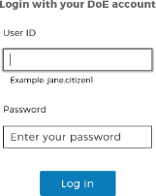

Logging onto the Student Portal & accessing emails
Access the Student Portal by navigating to https://portal.det.nsw.edu.au
Enter your User ID and password in the fields provided.
These are the credentials you would use to log onto a computer at school.
The portal page looks like the image below:
    - Click Email to access your Department of Education email address.
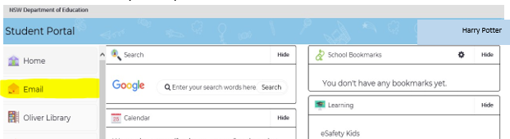
Find G Suite by clicking
on ‘Show more’
(3)
(2)
(1)

Accessing Microsoft Office 365
To access Microsoft Office 365 students should select the option under the Learning heading.
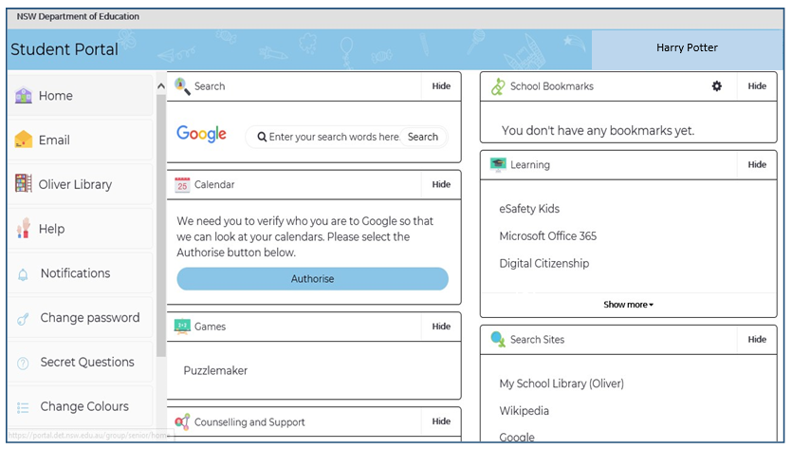
Once Microsoft Office 365 has been selected, the student will see:

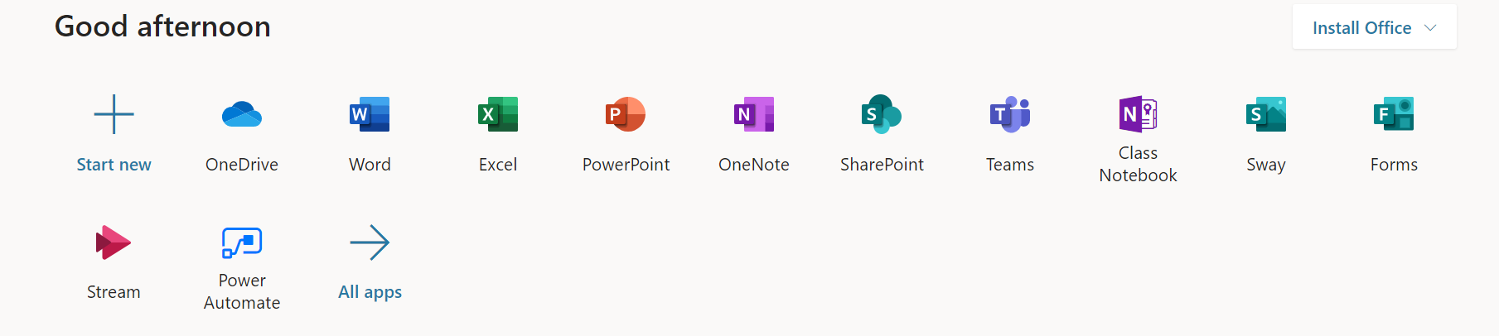

Students can use any of these applications and access their work by returning to Office through the student portal or by navigating to www.office.com and signing in using their school email address. All work created will be saved in the student’s OneDrive account (online). Therefore, work is not saved on your device, it is saved ’in the cloud’ and accessible from any device with an internet connection. Instructions are included in section 8 for adding OneDrive to your computer to automatically save documents into this cloud storage from Office desktop apps.

Installing Microsoft Office apps for students.
Students can access free downloads of the Microsoft Office suite while they are a student within the NSW Department of Education. To do this they follow the instructions below:
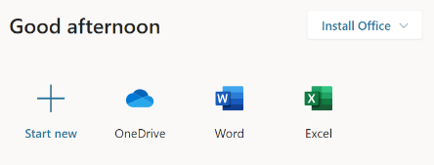
When logged onto Microsoft Office through the student portal (as in step 3.2 above), the Install Office feature (as shown on the right), allows the DoE user to obtain a free desktop copy of Office. This is tied to your DoE user account and needs to be signed into to stay licenced. Therefore, when you leave school
and lose your DoE account, it will stop working and you will lose access to all your documents in OneDrive. You can install this on up to 5 Windows and/or Mac devices and this version of Office will update to the latest available automatically.
Need some help on how to use Office 365? Click here!

Accessing and navigating Microsoft Teams
Willyama High School uses Microsoft Teams including OneNote to provide digital learning to students. Videos and tips for using Microsoft Teams can be found here.

Accessing Microsoft Teams
To access Microsoft teams, students select the Teams Icon in Microsoft Office 365 (to access Office 365 see section 3 above)

Accessing classes within Microsoft Teams
Once students have entered the Teams environment they will see a list of Teams they are members of. This may appear in two views. Tile view or list view. Both are shown below. To access a particular class, students click on the name of that team.
View 1:
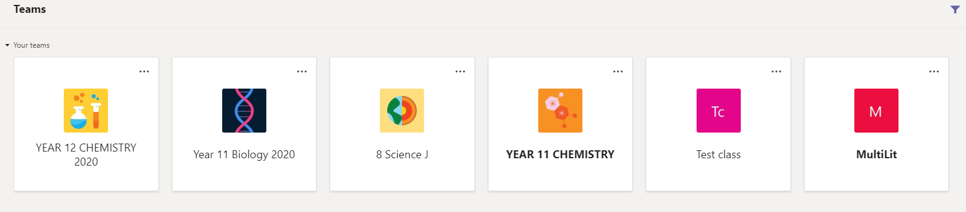
8 Science
8 English
8 Geography
8 PDHPE
8 Technology
8 Maths

View 2:
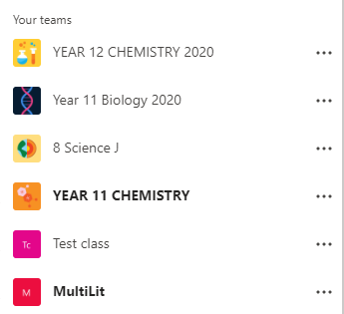
8 PDHPE
8 Geography
8 English
8 Science

Navigating within a Team
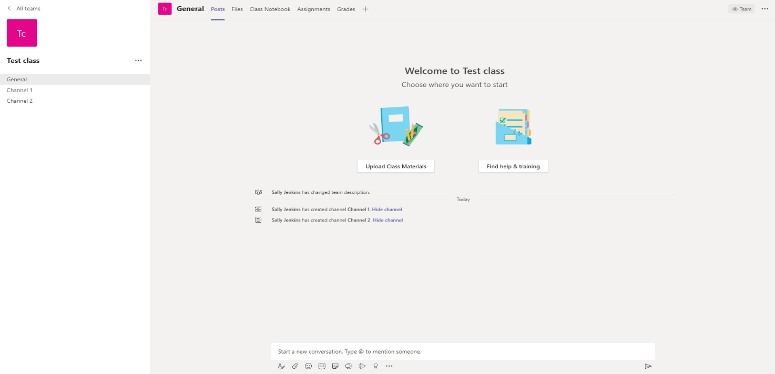
Once students have selected the team they will see the following view:

- The first page that students will come to when entering a team is the posts tab. This is where general conversation happens. Teachers can give instructions and students can ask questions. To type a question students type in the ‘start a new conversation’ box down the bottom. Students can also reply to teachers posts if they have questions.
- The second tab is the files tab. Copies of any documents that teachers want students to be able to view and download are found in the ‘class materials’ folder in files (See section 6). Note: Any other files posted in here that are not in the class materials folder are collaborative and editable for all members of a team. If a student would like to send a file to a teacher that other students cannot edit they should do this through Class Notebook (see section 5.4).
- Class Notebook is the third tab available for students. Class Notebook (OneNote) is covered thoroughly in section 5.
- The assignments tab is where students can complete assignments that teachers have set for them. When a teacher sets an assignment, students will be able to submit files through this tab.
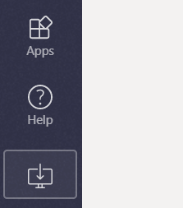
- These are your channels. Teachers may use channels to organise conversations and content. Within each channel there will be a posts tab and a files tab.

Downloading Microsoft Teams
Students can download the desktop app for Microsoft Teams. There are two ways of doing this.
Method 1: Once the student has accessed Microsoft Teams (section 4.1) they can select the install the desktop app by selecting download desktop app from the bottom left of the screen.

Method 2: Follow the instructions below to download and install Microsoft Teams

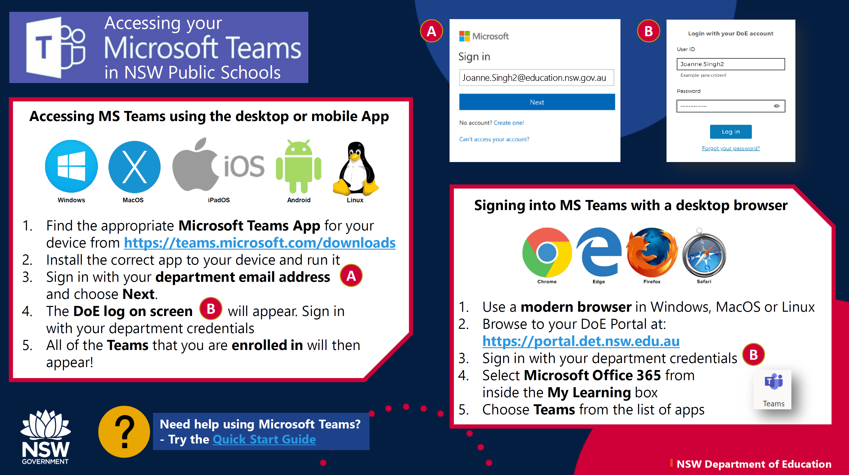

Class Notebook

Opening and navigating Class Notebook

To access their Class Notebook for a particular team, navigate to that Team and click on the Class Notebook (3) tab from the above picture.
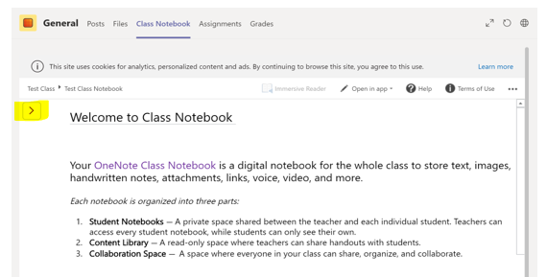
This will open the landing page for the Notebook.

To see the Content Library and their Student Notebook students will need to click the arrow at the top left corner of the Notebook.
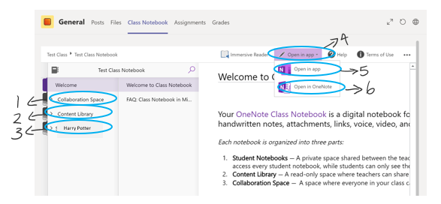
This will allow them to see:
Harry Potter

- The Collaboration Space, a tab when everyone, including teachers and students, can edit all pages.
- The Content Library, a tab where notes and activities can be found. All pages in here are added by the Teacher and can only be edited by the Teacher. They are read-only for students. If you want to edit a page from the Content Library, you need to copy and paste that page into your Student Section (3) (See section 5.3 for instructions on how to do this).
- The Student section tab. This will display the student name on the tab. Everything in here is visible only to the Teacher and that student. All content in here can be edited by the student. Students need to click into the section and then onto a page to allow them to edit. If this does not allow them to edit students will need to select the open in app (4) button.
- The open in app button will give students two options. These are open in app (5) or open in browser/OneNote (6).
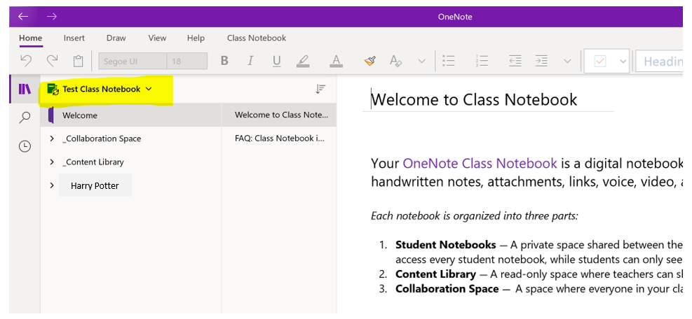
- Selecting open in app will open the OneNote app on the computer. You may be required to sign in to this app. If so, you will need to use the email address listed in Section 1.2. Once the app is open you can use the dropdown box in the top left corner to switch between your Notebooks. Further information on using the OneNote app can be found in this video.
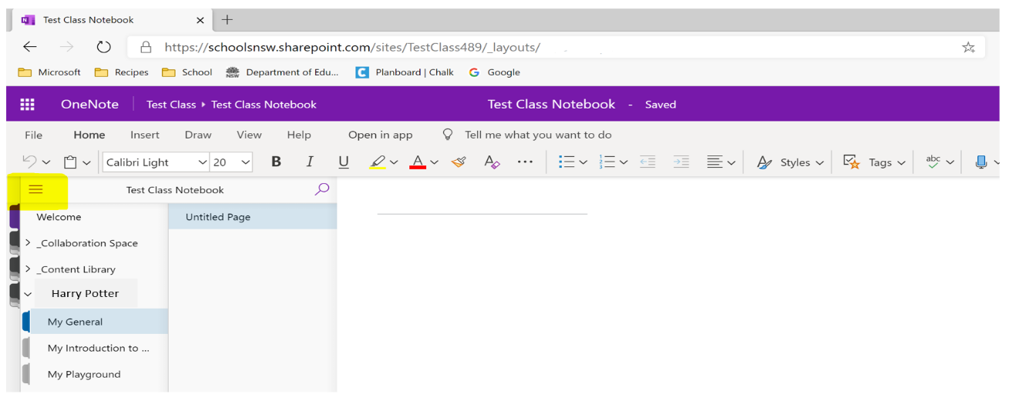
- Selecting Open in OneNote/Browser will open the notebook in OneNote online. This is a lighter version of OneNote than the app and will sync quicker if the OneNote server is busy.

Clicking the three vertical lines in the top left corner will give you a list of your notebooks and allow you to switch between them. Further information on working online in OneNote can be found in this video.

Working in Class Notebook
Class Notebooks are saved online in Teams. For this reason it is important to know when the work you have been doing is saving and when OneNote needs more time to sync so that you know your work is safe and that your teacher can view your progress.
The two screenshots below show how you know that your work is saved when working in either the app or the browser.
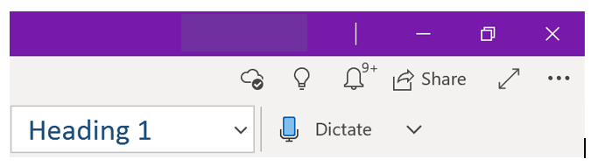

The first image shows the app. You know that your work has synced with the cloud storage when you see the small cloud with a tick in it, as highlighted above.
The second image is the browser. You know your work is saved when you have the saved message next to the notebook.
If you do not have these messages/symbols you may need to give your OneNote some more time to sync. When working in the app, if your work has not synced, you can click the space where the cloud should be (there will likely be another symbol there, either an error or two circular arrows) and tell the notebook to sync again.

Copying and pasting pages in OneNote

Occasionally your teacher might ask you to copy a page out of the content library and into your own Notebook so that you can work on it. To do this follow the steps below.
Step 1: Right click on the page you would like to take from the content library.
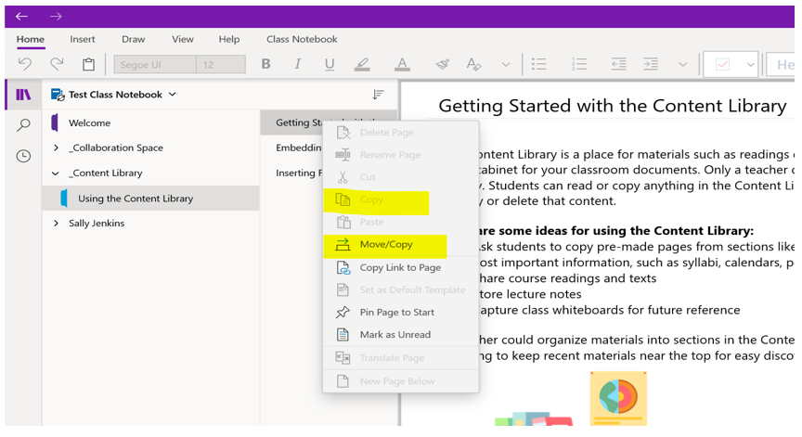
Step 2: Select copy. If copy is not available you will need to select move/copy and select the section in your Student Notebook that you would like to place the page, then click the copy button.
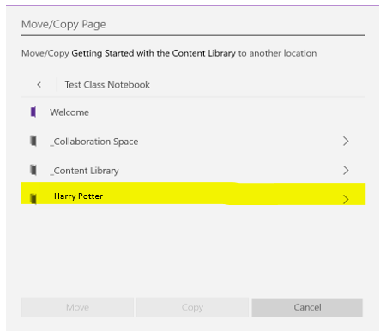
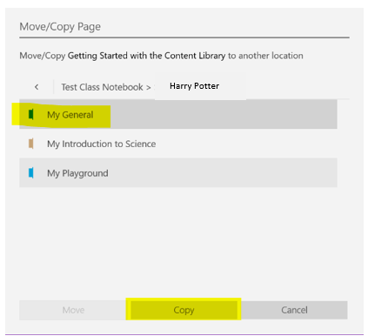

Step 3: If you have been able to select copy from Step 2, navigate to your Student Notebook and click the section you would like to put the page in. You can then right click on a blank space under the listed pages and select paste. This will move the page into your Student Notebook and you will be able to edit the page.
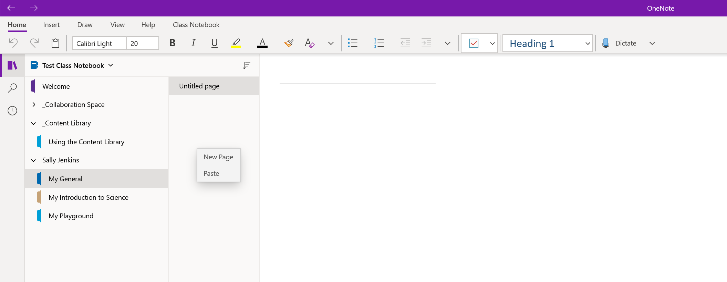
Harry Potter

Adding a file in Class Notebook

If you would like to share a file with your Teacher that only you and the teacher can see, you can do this in Class Notebook. To add a file, you navigate to your file explorer and select the file you would like to insert. You can then drag and drop the file onto the page you would like to add it too.
This will provide you with three options:
- Upload to OneDrive and insert link. This will place the file into your personal OneDrive and put a link to the file into the OneNote. This is useful if you want the teacher to be able to look at your work. It is important to note that any edits they make will save to the file in your OneDrive.
- Insert as attachment. This will place a copy of the file into your OneNote. The teacher will be able to open this and comment on it or edit it. You will be able to see any changes reflected when you click into the attachment.
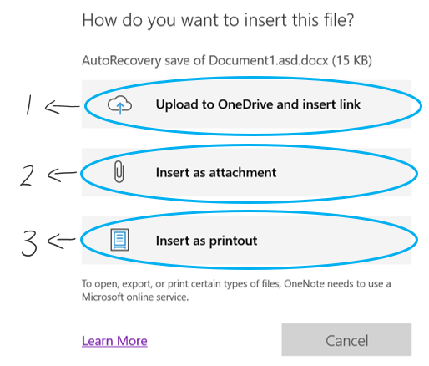
- Insert as a printout. This will put each page of the document onto the OneNote page you are working on. This is useful if you would like to put notes on the page or if you would like a quick view of the document. This allows the teacher to leave feedback on the page for the work you have done.

Files in Microsoft Teams

Accessing files in Teams
Students may need to access files within teams to collaborate on documents or to download class materials. To see files that have been added to a team, navigate to the files tab within the class team (see section 4.3). When students navigate to the files tab within the general channel, they will see the class materials folder. There may also be other files there that students can edit.
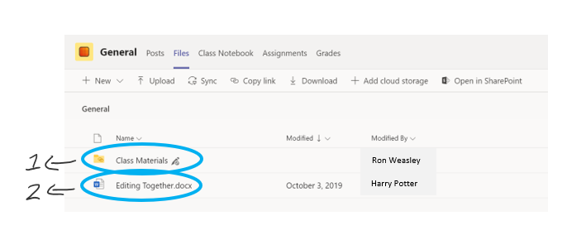

- The class materials folder is where teachers may upload files for students to view. Anything that is saved in here cannot be edited by students, however, students may download their own copy to work in.
- Any other file in this section is a collaborative document. This means everyone can edit the document.

Editing or downloading files from Teams
To download a file from Teams, select the three small dots to the right of the file name. This will bring up a document menu. You can select download from this menu.
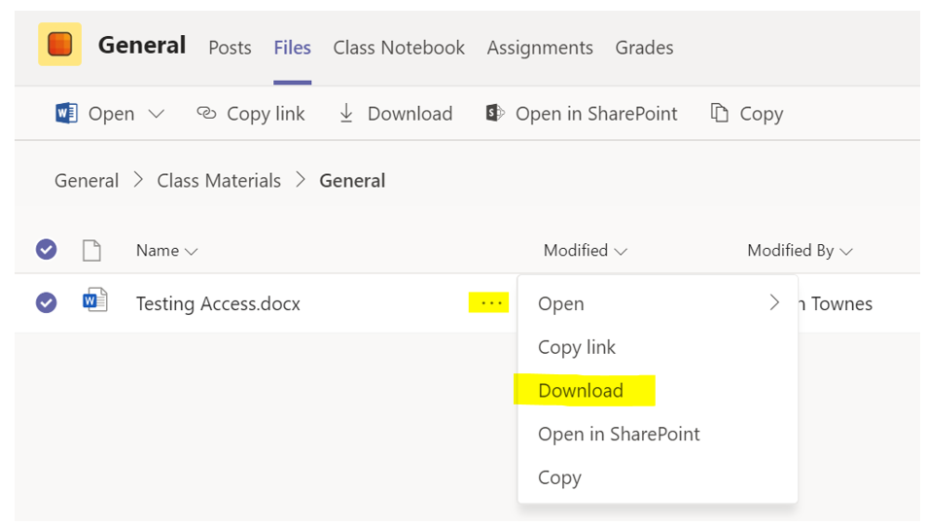

To edit a collaborative document, select the three small dots to the right of the file name to bring up a document menu. Click on the Open (1) option. This will give you three options for opening the document.
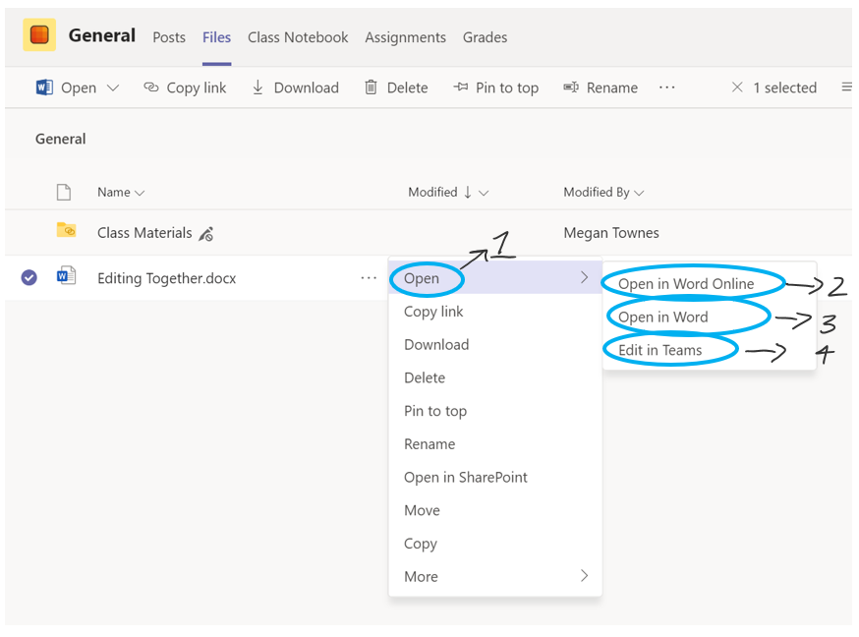
- Selecting Open in Word Online will open the document in a browser. Students will be able to edit from this screen. The file will continually save and sync back to teams.
- Selecting Open in Word will open the desktop version of Word if it is installed on the computer. This file will still be live online, it will not download a local copy onto the computer. All changes that you make will automatically save back to Teams when you click the save button.
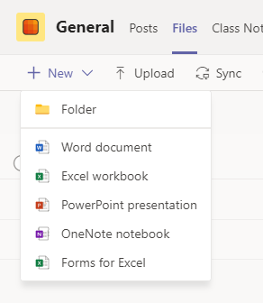
- Selecting Edit in Teams will open the file within the Teams window and allow for you to edit it. All changes will save automatically.

Adding a file to Teams
To add a file to Teams, students can drag and drop the file from their file explorer into the files section.
You can also create Word, PPT and Excel documents directly in teams by selecting the + New button in the top right corner of the tab and selecting the file type you would like to create. This will create a blank document within the team that you can edit.

Video conferencing in Microsoft Teams

Joining a meeting in Microsoft Teams
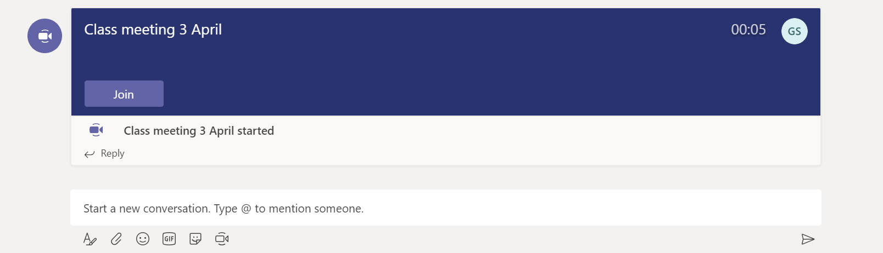
Teachers can host meetings for their students. These allow a forum for asking questions or getting help from your teacher. Teachers will set a scheduled time for this meeting to happen. To join the meeting you will need to go to the Team and channel where the meeting is starting (your teacher will give you this information). Once the teacher starts the meeting you will see the option to join the meeting. Selecting this will add you to the meeting. You should always join a meeting with your microphone muted. You can unmute your microphone during the meeting when you want to speak.
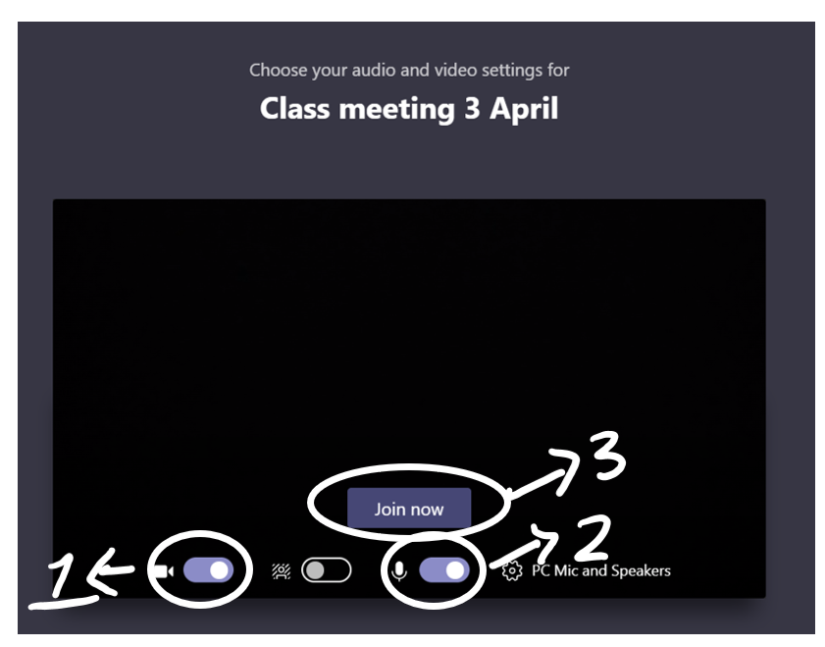
- This is where you toggle your webcam on or off. It is good practice to leave your camera off when in a meeting as this reduces the strain on the internet to be able to stream the meeting. Your teacher may have their camera on so that they can show you content or speak to you, but in most situations, it is better for you to leave your camera off. Your teacher may ask you to if you want to turn your camera on or share your screen to show them something.
- This is where you toggle your microphone on or off. You should join meetings with your microphone off and only turn it on when you need to speak.

- Once you have your microphone and audio toggles set, you can press the join now button. This will take you into the meeting environment.

Etiquette online during a meeting
When you are participating in an online video call or meeting there are some basic rules you should follow:
- Be polite and respectful
- Do not make any inappropriate comments
- Keep the topic of discussion on schoolwork
- Mute audio when not speaking to reduce feedback noise
- Dress appropriately

Accessing meeting chat while in a meeting
You may not feel confident in speaking during the meeting or may prefer to communicate to your teacher via the meeting chat. To do this, you hover over your meeting bar and select the conversation icon.
This will bring up the conversation for the meeting along the right side of the screen. Be aware that anything you post in here is still visible to everyone in the meeting.

Downloading and using OneDrive

Downloading OneDrive and logging in
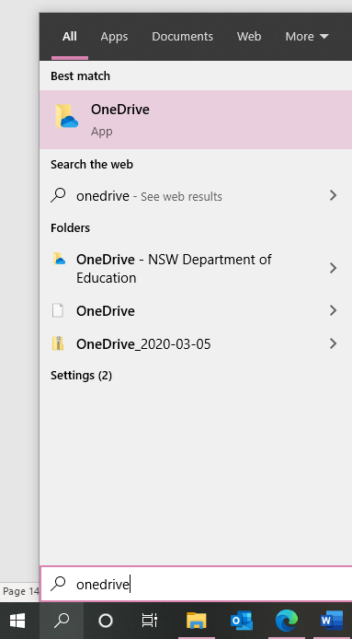
OneDrive is the cloud storage associated with Microsoft Office 365. You can access OneDrive online by clicking on the OneDrive cloud icon in www.office.com as shown in section 4.1.
OneDrive for Windows 10
If your computer is running Windows 10, OneDrive will already be installed. You can find it by searching OneDrive in your taskbar. You will need to sign in using your email address from section 1.

OneDrive for all other platforms
OneDrive can also be installed from this link. You will need to download and run the program and sign in using your email address from section 1.

Using OneDrive

Once you completed the steps from 8.1 above, you can commence using OneDrive in the same way that would use any other folder on your computer. Your OneDrive folder should appear on the left of your Windows Explorer navigation pane as in the image below. You can add folders and files to your OneDrive and these will be stored in the cloud and can be accessible on any other device that you have linked to your OneDrive school account and also available anywhere through OneDrive online at www.office.com
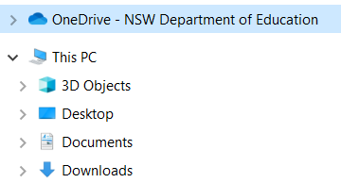
When you open a file through OneDrive and make changes to it and save it, it will automatically sync this updated file to your cloud storage allowing you to access the updated document on any other device or online.
Using this type of file storage is beneficial because you always have a backup of your files saved to your clou
Remember, your teachers are here to help you! Reach out via phone, email or your digital classroom if you need help

